

Draw it or Lose It

# **CS 230 Project Software Design Template**

Version 1.0

## Table of Contents

**CS 230 Project Software Design Template**1

**Table of Contents**2

**Document Revision History**2

**Executive Summary**3

**Design Constraints**3

**System Architecture View**3

**Domain Model**3

**Evaluation**3

**Recommendations**5

## Document Revision History

| Version | Date | Author | Comments |
| --- | --- | --- | --- |
| 1.0 | 05/30/2021 | Jamiya Ennis | <Brief description of changes in this revision> |

**Instructions**

Fill in all bracketed information on page one (the cover page), in the Document Revision History table, and below each header. Under each header, remove the bracketed prompt and write your own paragraph response covering the indicated information.

## Executive Summary

The world has been experiencing difficulties in developing games that can serve multiple platforms. One of the most common factors that has hindered the growth of these games is the need for players to be able to draw images while playing. Creative Technology Solutions, a leading game developer company, has been working with The Gaming Room, to develop a web-based game that will serve multiple platforms. This app will allow players to draw images using a large library of stock drawings instead of using an easel to produce clues. Creative Technology Solutions has experienced a sudden rise in demand due to the emergence of new games that can be deployed across various platforms. The Gaming Room is developing a web-based game based on their current game Draw It or Lose It. The app will allow players to collect clues using stock drawings.

## Design Constraints

During the design phase, there are few constraints that you need to consider. These constraints help the developer visualize the various requirements and provide a visual awareness of the software. Examples of these constraints are ESS diagram, UML diagram, and class diagrams.

## Domain Model

The following seven classes are represented in the UML diagram: programDriver, singletonTester, entity, gameservice, team, and player. Each of these classes has its own parent interface. GameService, Game, Team, and Player have an association connection in which each entity is dependent on the other. the singlectonTester class derives from the programDriver class, which is the main class. As previously said, inheritance is the most important object-oriented programming paradigm used in this UML diagram. It has given the singlectonTester class the ability to conduct activities and responsibilities that the main class has inherited.

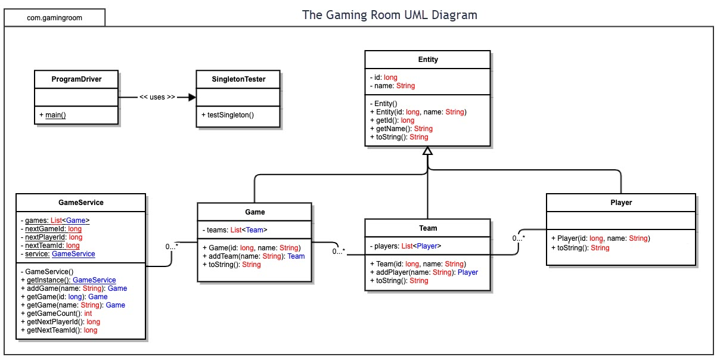

## Evaluation

Using your experience to evaluate the characteristics, advantages, and weaknesses of each operating platform (Linux, Mac, and Windows) as well as mobile devices, consider the requirements outlined below and articulate your findings for each. As you complete the table, keep in mind your client’s requirements and look at the situation holistically, as it all has to work together.

In each cell, remove the bracketed prompt and write your own paragraph response covering the indicated information.

| **Development Requirements** | **Mac** | **Linux** | **Windows** | **Mobile Devices** |
| --- | --- | --- | --- | --- |
| **Server Side** | It is widely used in web hosting and is upgradeable, with a variety of choices to meet varied web hosting needs. For web hosting services, it is less popular. | It is the most recommended choice for web hosting services since security problems are identified before they become an issue. Finding an application to support the web hosting requirements is more complicated. | It is dominant to the other platforms. High resource requirements, less loading time, high comfort ability. easy virus susceptibility, poor technical support. | Popularity and portability. Has a greater reach, better compatibility, and is less expensive. It caters to a wide range of smart mobile devices. Inadequate security. |
| **Client Side** | To design software for Mac clients, you'll need a lot of experience. It is costly because the clients are charged on a monthly basis. Accessing the software takes a long time. | Due to the limited number of applications available, it necessitates a high level of skill. Loading time is reduced. It's pricey since it's not well-known. | It necessitates a high level of skill because to the significant resource requirements. Loading time is reduced. It is costly since it necessitates the use of greater resources. | It is a cost-effective solution. It takes less time for a page to load. It is common, and as a result, it provides excellent technical support to clients. |
| **Development Tools** | PHP programming language  JavaScript | PHP programming language | Java programming,  HTML/CSS  Netbeans | Android Studio, Android programming |

## Recommendations

Analyze the characteristics of and techniques specific to various systems architectures and make a recommendation to The Gaming Room. Specifically, address the following:

1. **Operating Platform**: It is usual to develop web-based software, the Windows Operating System is the recommended environment. It is highly secure, has a short loading time, and is reasonably priced. It is compatible and portable, making it ideal for the creation of the game Lose It or Draw It.
2. **Operating Systems Architectures**: The user model and kernel model are the two fundamental components of the Windows operating system. It's a preemptive and reentrant operating system that may run on either symmetric multiprocessors or single processors. User mode programs and subsystems have limited access to system memory and external devices, whereas kernel mode programs and subsystems have full access to system memory and external devices. It processes input/output requests using packet-driven I/O.
3. **Storage Management**: The finest storage system that will perform successfully and efficiently with Windows is the database management system. This storage system is suited for Windows due to its excellent compatibility. It's simple to use and runs on a variety of operating systems. It's also extremely adaptable.
4. **Memory Management**: Windows uses a memory compression approach to accommodate the extensive use of the Draw It or Lose It applications. This will improve the operating system's responsiveness. When the quantity of memory required by the Draw It or Lose It software exceeds the amount of RAM available, Windows will begin removing pages of memory from RAM and temporarily storing them on the hard disk.
5. **Distributed Systems and Networks**: The distributed system will use hubs to connect numerous computers using LAN as the networking protocol, allowing the game to continue to run even if one machine fails. The hub will also function as a repeater, amplifying transmissions that weaken over long distances. With LAN as our stable network and Hub as our connectivity gear, the system will experience less outages overall.
6. **Security**: Protection measures will be taken to preserve the confidentiality of the clients' information. This application's security will be based on the encryption of the clients' personal information. Because of the excellent security features of the Windows operating system, users will be better protected from intruders.